**Phase 5 project**

**CI/CD Deployment for Springboot Application**

**OUPUTS:**

**Flow chart:**

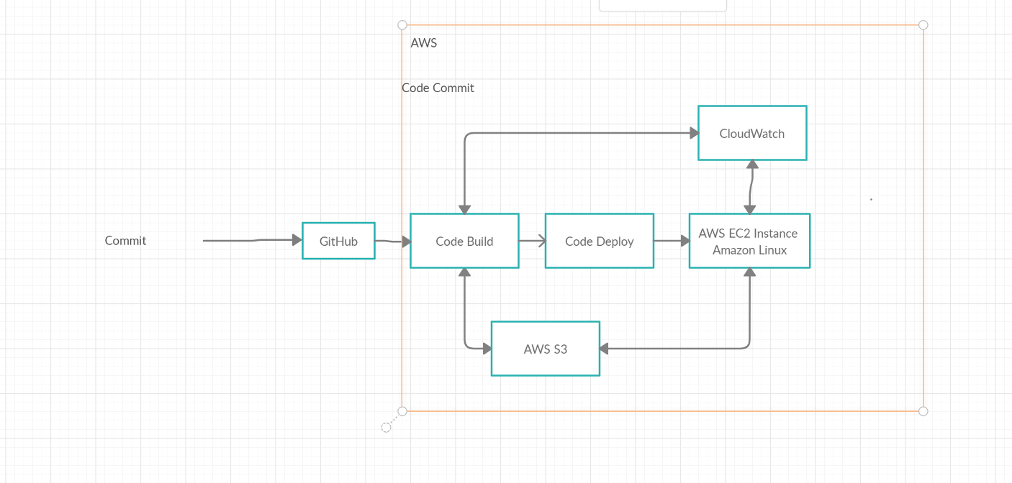

# Eclipse

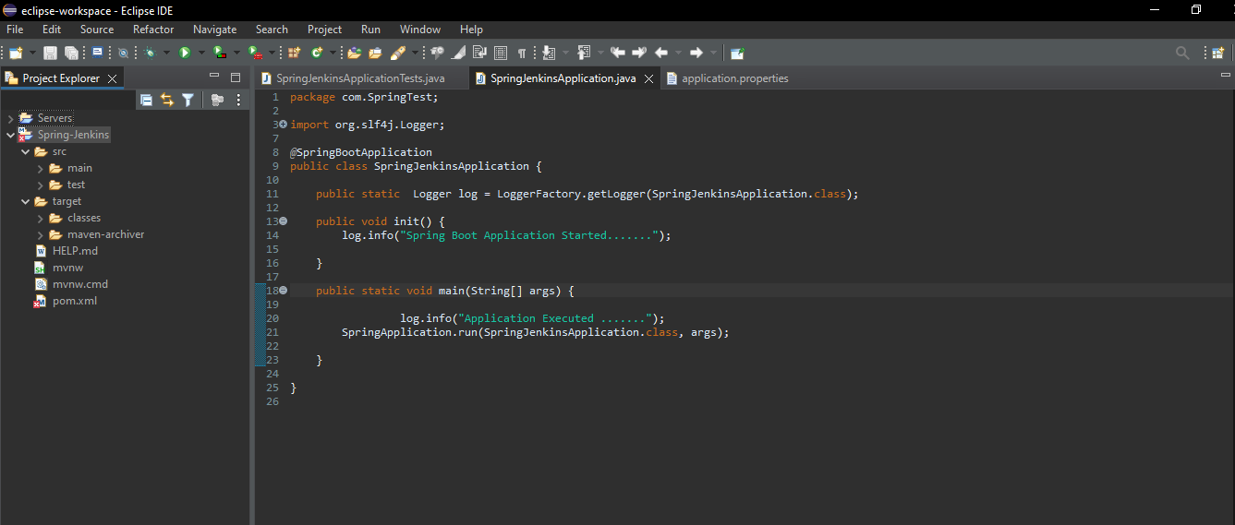

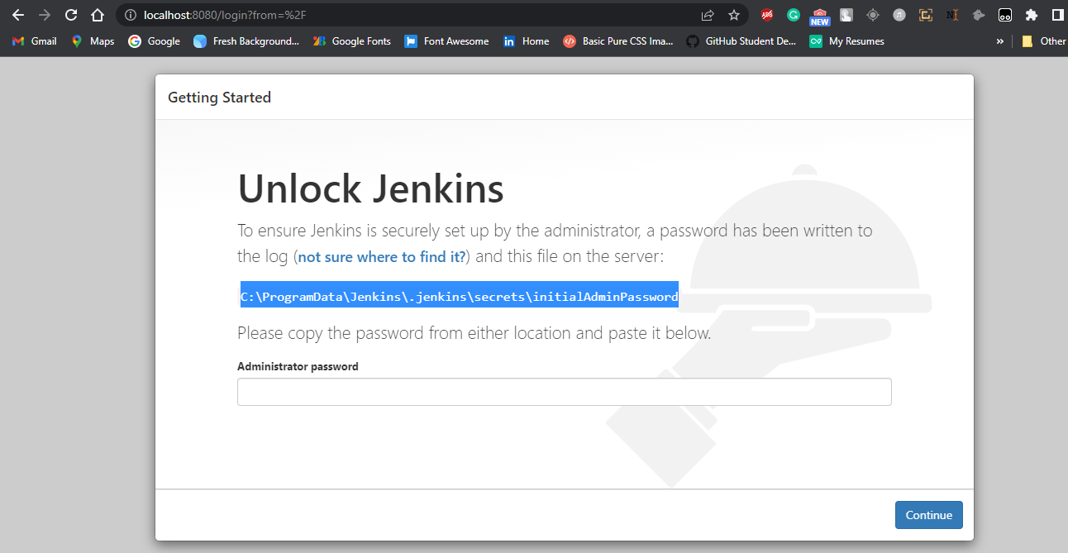

# I create Simple Spring boot Application to build a CI/CD pipeline to demonstrate continuous deployment:

## 

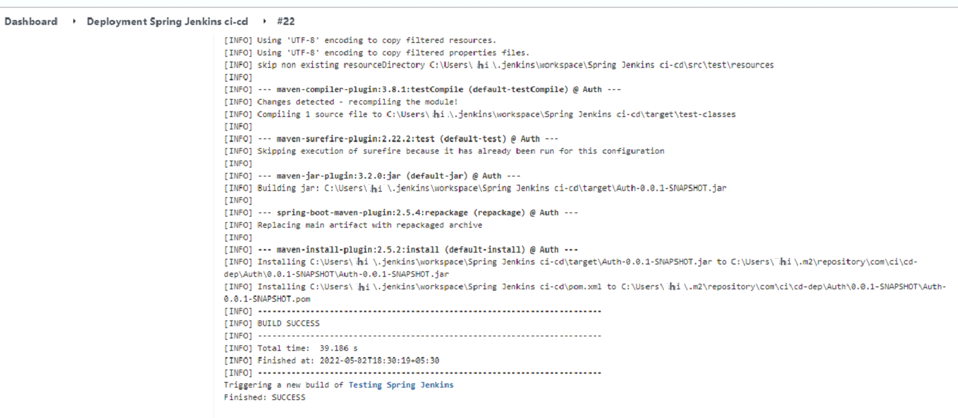

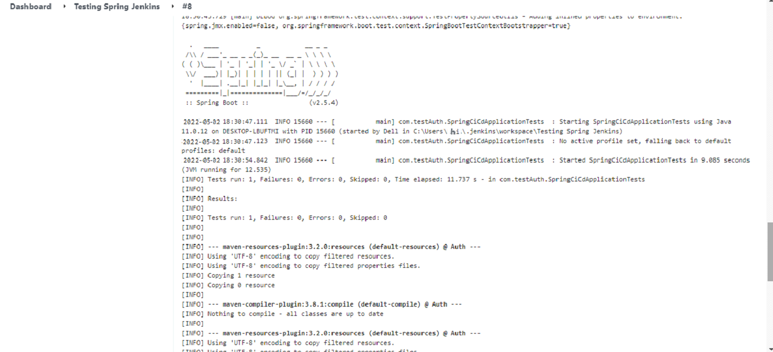

# Git Hub: Application Deploy on git Hub

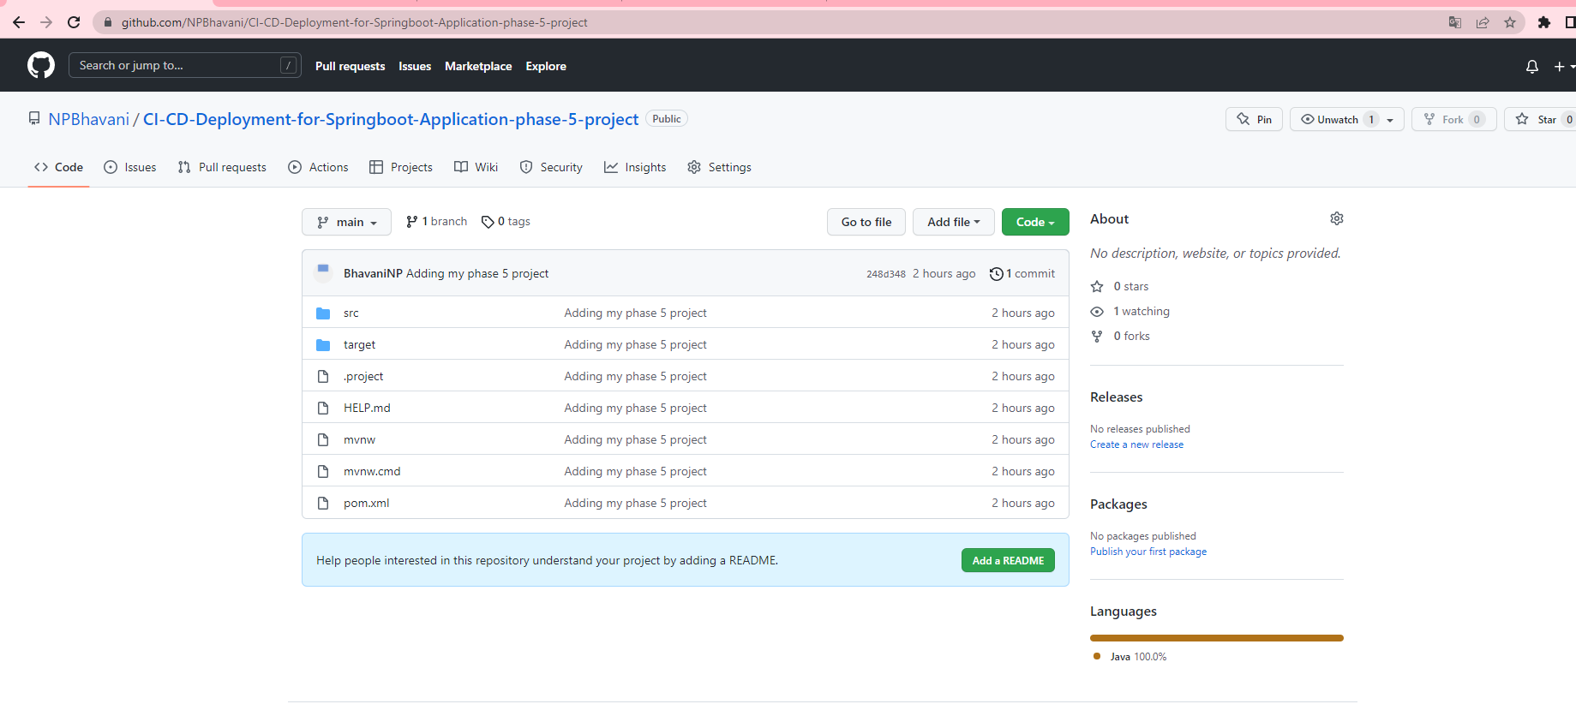

**Github repository:**

<https://github.com/saiganesh7888/Phase-5-Project.git>

# Jenkins : Run Jenkins

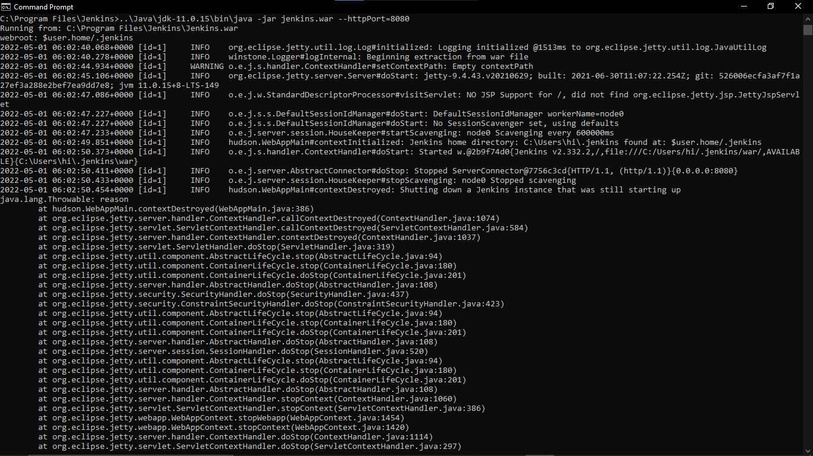

**CREATE THREE JENKINS PROJECT DEPLOYMENT:-**

**DEPLOYMENT-TESTING-PRODUCTION**

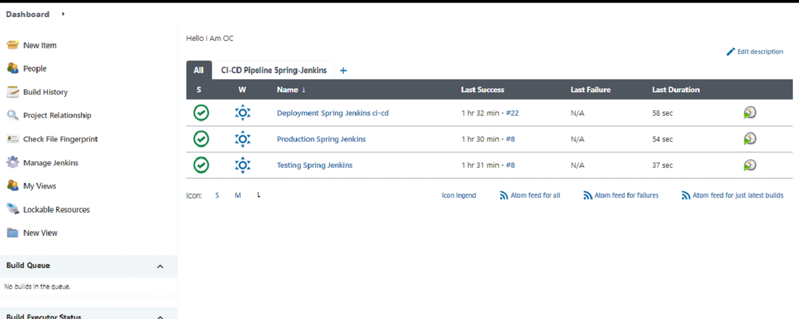



**Final Output:-**

**Last host the application on AWS EC2 instance:**

